Tuesday 2nd June

Dear Parent/Carer,

I hope you have enjoyed the sunny weather and have all been in good health. Hopefully, your child took advantage of the half term to practice their singing for the virtual concert.

I am writing to update you on the latest information on when and how to upload your child’s video’s so that it can be edited and uploaded to Youtube.

The completed video will be published as unlisted so that family, friends, and others may view it if they receive the link, but it should not be on view to the wider public. For safety reasons the names of individual children will not be included in the video, just the names of schools and Haringey music groups involved. If you agree to allow your child’s video contribution to be made used in the manner described above, please complete the form below if you have not done so already.

The aim is to broadcast the virtual concert on YouTube at 7:30pm on 30th June 2020 and we will send a link nearer the time. We need to get our individual videos to Haringey Music Service by 5th June at the latest, to allow time for editing it all together. Please see below, on second page, for detailed instructions on how to take part.

Yours sincerely,

Ayse Thomas

-----------------------------------------------------------------------------------------------------------------------

Consent form for Choir Club Video Upload to YouTube

Child’s Name: _________________________ Class: _____________________

I give consent to South Harringay School and Haringey Music Service to edit my child’s videos and upload them to YouTube for public view.

Parent name: __________________________ Signature: _____________________

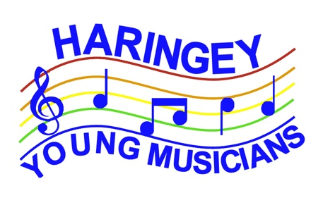
TAKING PART IN THE VIRTUAL PERFORMANCE SINGERS
What you will need:
- 2 devices - one to play the demo recording into your headphones and one to film yourself playing at the same time. This could be 2 phones or any combination of smart phone, computer, tablet etc. Use the one with the best camera to do the filming
- A pair of headphones. The best technique is to have in-ear headphones and only put one in so you can hear yourself sing clearly while also listening to the track
- A printout of the words. There will be a pdf file attached to the email
- A well-lit room for filming. The background should be as plain as possible and the light should be in front of you so that your face is well lit. Probably best to have the window behind the camera
What to do to prepare:
- Print the lyrics (or open on a screen)
- Watch the demo videos
- Practise the singing and the actions along to the demos
Making your video:
- Use a stand (or improvise one) to hold the filming device steady - choose landscape
and make sure we can see all of your actions and all of your face
- Make sure you are clearly in shot and not too far away
- Make sure the light is in front of you and behind the camera
- Have as plain a background as you can
- Wear your concert clothes
- Make sure the room is quiet and not too echoey
- Sing straight at the camera
- If possible, make it look as if you are not wearing the headphones
- Film yourself singing along to the recording, making sure the sound of the demo cannot be heard on your video. Sing loudly and make it look as if you are enjoying performing in the Royal Albert Hall!
- Upload your video according to the instructions in the email using the link here:
https://drive.google.com/drive/folders/18w8UZc4s2TadJmcP0OIGbjEB5YYkHi0A?usp=sharing

Peter Desmond May 2020

