**SRE Book recommendations**

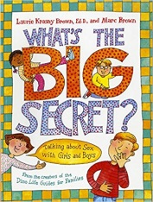

1. [*What’s the Big Secret?*](http://www.amazon.com/gp/product/0316101834/ref=as_li_ss_tl?ie=UTF8&camp=1789&creative=390957&creativeASIN=0316101834&linkCode=as2&tag=terminaintell-20) by Laurie Krasny Brown  
Appropriate age: 4+  
Approach: Best used to begin the conversation.  
Answers questions like: Are boys and girls different on the inside? How do you tell girls and boys apart? Do girls and boys have the same feelings? Is sex a dirty word? Where do babies come from? What does being pregnant mean? How do you get a belly button? Tell me about when I was a baby...

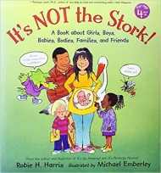

2. [*It’s Not the Stork!*](http://www.amazon.com/gp/product/0763633313/ref=as_li_ss_tl?ie=UTF8&camp=1789&creative=390957&creativeASIN=0763633313&linkCode=as2&tag=terminaintell-20) by Robie H. Harris and Michael Emberley  
Appropriate age: Around 5+, use your judgement.  
Approach: Quality reading time, and answering questions.  
This is a great resource for answering young children’s questions. The text in this book is moderately explicit, using terms such as penis and vagina, but has no explicit images. The adults do things “under the covers” in the illustrations, but the text does not evade answering questions. Advertised for kids as young as 4, remember to use your judgement. If nothing else, it’s a great book for the first “talk.”

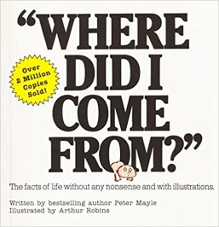

3. [*Where Did I Come From?*](http://www.amazon.com/gp/product/B009CPLS6E/ref=as_li_ss_tl?ie=UTF8&camp=1789&creative=390957&creativeASIN=B009CPLS6E&linkCode=as2&tag=terminaintell-20) by Peter Mayle  
Appropriate Audience: Around 5+, use your judgement  
Approach: Quality reading time for one-on-one discussion.  
*Where Did I Come From?* has been popular for generations of families. With tasteful but accurate illustrations, kids are introduced to the basics of life. This is a great book for answering enough questions to put off a bigger “talk.”. It answers all the right questions, and provides a “cute” picture book for learning anatomy. Great for the nursery coming home with more questions than you are ready for.

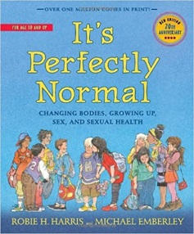

4. [*It’s Perfectly Normal: Changing Bodies, Growing Up, Sex, and Sexual Health*](http://www.amazon.com/gp/product/0763644846/ref=as_li_ss_tl?ie=UTF8&camp=1789&creative=390957&creativeASIN=0763644846&linkCode=as2&tag=terminaintell-20) by Robie Harris and Michael Emberley  
Appropriate audience: 10+  
Approach: Read some together, then let the book do the talking. Answer questions appropriately.  
This thorough guide to changing bodies, growing up, sex, and sexual health does a great job covering all the bases, including embarrassing erections! The newest edition now includes a chapter on the safe use of the Internet. The illustrations are for older kids, but are creative and eye-catching. If you are looking for upfront and non-biased information, this is easily the best bet for anyone over 10. Definitely use your judgement, though. You know what’s best for your kids.