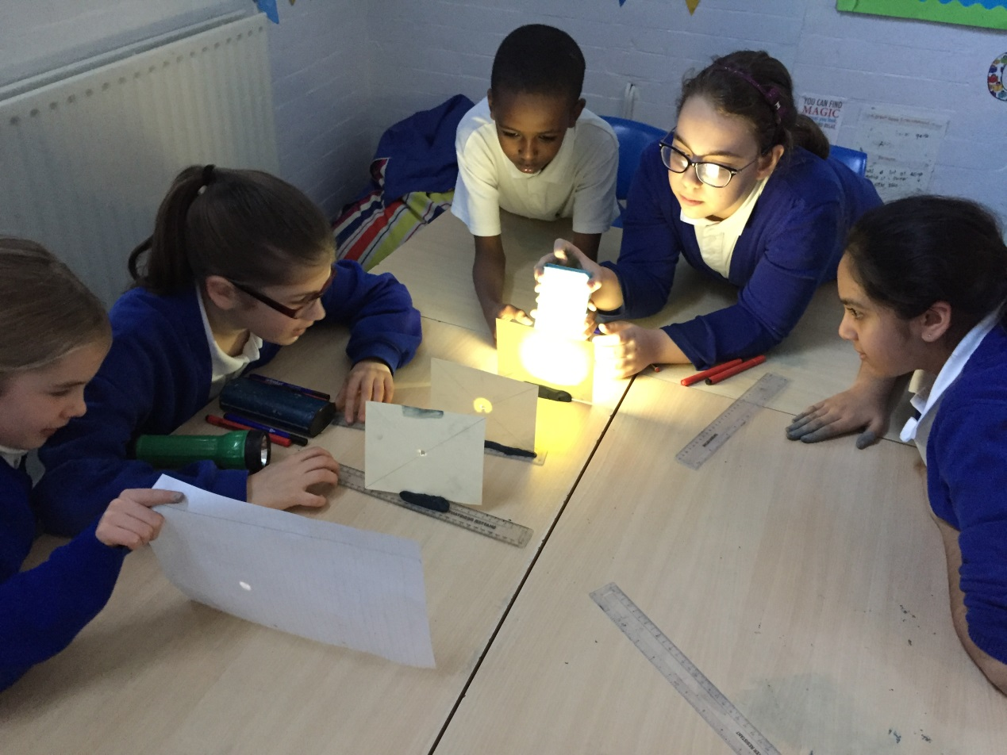

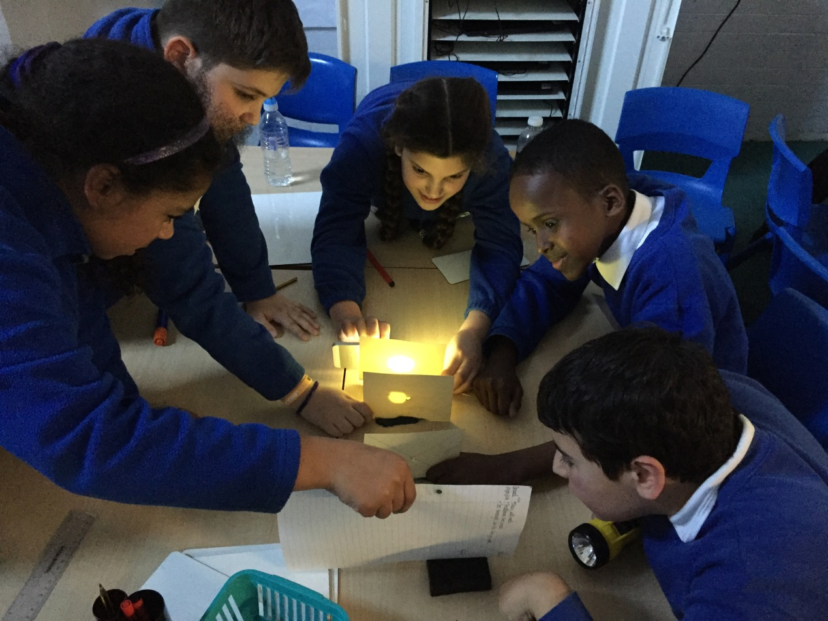

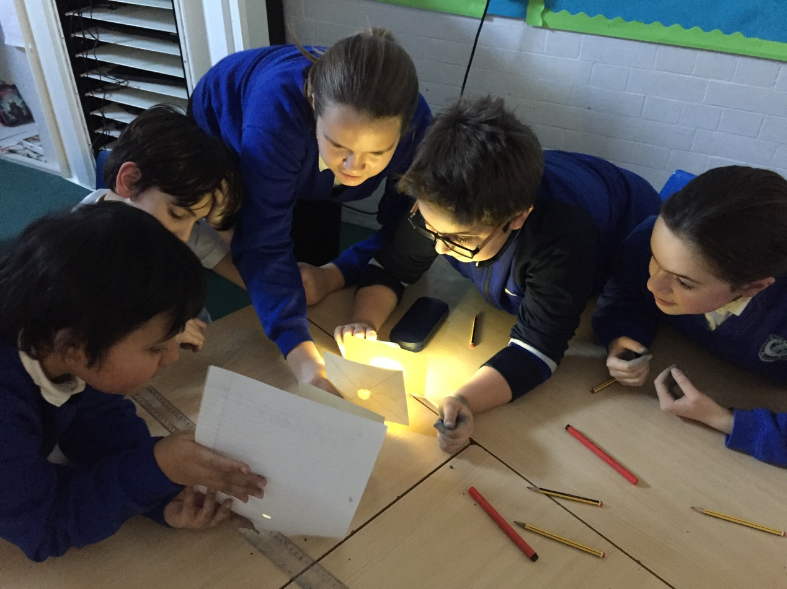

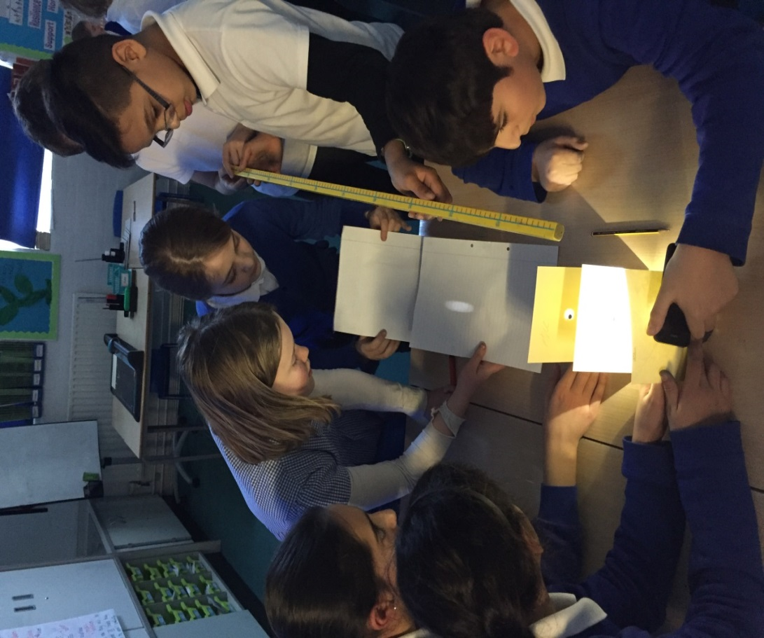

In Year 6, we are currently learning about ‘Light’. For this task, we were conducting our own experiment on how light travels. We pierced holes through 3 different pieces of card (in a straight line), and fastened them to the table using clay. Then, we used a torch to observe whether the light would travel through all three holes on to the last piece of paper. When the holes were not in a straight line, the light did not travel through to the last piece of card. We therefore concluded that light travels in straight lines.